# The HTML5 Canvas

## Low-level graphics in the Web

# Table of Contents

* Overview and usage of the canvas
* Drawing shapes
  + Rectangles, arcs and ellipses
  + Lines, paths and Bézier curves
* Drawing Text
* Per-pixel manipulations
* Canvas styles
  + fillColor and strokeColor
  + Gradients, patterns and shadows
* Transformations
  + Save and restore context state
  + Translate

# The HTML5 Canvas - The way of the graphics in web

# The HTML5 Canvas

* The Canvas is the way to draw in the browser
  + Uses JavaScript for the drawing
  + Enables high-performance drawing
* The Canvas is part of the HTML5 specification
  + Supported in most browsers
    - Both desktop and mobile

# Using the Canvas

* The Canvas is a rectangular sheet
  + All the drawing is done inside this sheet
* The canvas consists of:
  + <canvas> HTML element
  + JavaScript API for the drawing

// Set width and height

<canvas id="the-canvas" width="100" height="100" />

var canvas = document.getElementById('the-canvas');

var canvasCtx = canvas.getContext('2d');

canvasCtx.fillRect(10, 10, 30, 30);

# The HTML5 Canvas Context

* The canvas HTML element provides many ways for drawing
  + Rectangular 2d drawing
  + 3d drawing
  + WebGL drawing
* HTML5 provides APIs for all these types of drawing
  + The way to use a specific canvas API is to get the corresponding context

# *Using the HTML5 Canvas - Live Demo*

# Drawing Shapes (Rects, Arcs, Ellipses)

# Canvas Shapes

* The Canvas provides ways to draw all kinds of shapes
  + Rects, arcs, ellipses, lines, etc…
* Each of these shapes can be either
  + Drawn in full color (i.e. filled)
  + Drawn only their border (i.e. stroked)

var canvas = document.getElementById('the-canvas');

var canvasCtx = canvas.getContext('2d');

canvasCtx.fillRect(10, 10, 25, 25);

canvasCtx.strokeRect(10, 10, 25, 25);

# Drawing Rects

* Drawing rects is the simplest way to draw with the canvas
  + Build-in functionality
  + context.fillRect (x, y, width, height)
    - Creates a rectangular shape at position (x, y) from the top left corner of the canvas
    - The shape is drawn in full color
  + context.strokeRect (x, y, width, height)
    - Same as fillRect
    - Only the border of the shape is drawn

# Drawing Rects: Example

* Drawing a rectangle filled with light blue and with dark blue border

<canvas id="rects-canvas"> </canvas>

var canvas = document.getElementById('rects-canvas'),

ctx = canvas.getContext('2d');

ctx.fillStyle = 'rgb(107, 187, 201)';

ctx.strokeStyle = 'rgb(2, 55, 155)';

ctx.fillRect(20, 20, 140, 90);

ctx.strokeRect(20, 20, 140, 90);

# *Drawing Rects - Live Demo*

# Canvas Paths - Drawing arcs and lines

* The Canvas can do much more than just drawing rectangles
  + Bezier curves, ellipses, arcs
  + Much of the power of the Canvas comes from the path
* The path is just a set of connected dots
  + Depending on the method used, the dots can be connected using straight line or curve
* The canvas context has methods for paths:
  + beginPath()
    - Starts path
  + moveTo(x, y)
    - Changes the position of the path marker
  + lineTo(x, y)
    - Draws a straight line from the position of the path marker to position (x, y)
  + fill() / stroke()
    - Fills or strokes the path

# How the Canvas Works?

* The canvas only marks dots on the canvas sheet
  + And remembers how these dots are connected
  + When fill() or stroke() is reached, all dots are connected at once

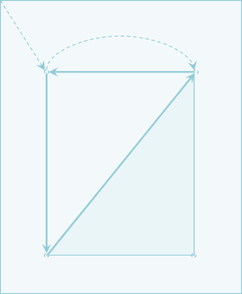

ctx.beginPath();

ctx.lineTo(200, 50);

ctx.lineTo(50, 50);

ctx.stroke();

ctx.beginPath();

ctx.moveTo(200, 50);

ctx.lineTo(200,300);

ctx.lineTo(50, 300);

ctx.closePath();

ctx.fill();

# *Using the Path - Live Demo*

# Drawing Ellipses - Using the path

* The Canvas has a built-in methods for drawing ellipses
* arc(x, y, radius, from, to, counterclockwise)
* Draws a circle with center at (x, y) from position "from" to position "to"
* Positions in ellipses are   
  described using radians (degrees)
* The degrees to radians formula is:
  + **radians = degrees * PI/180**

# Degrees and Radians

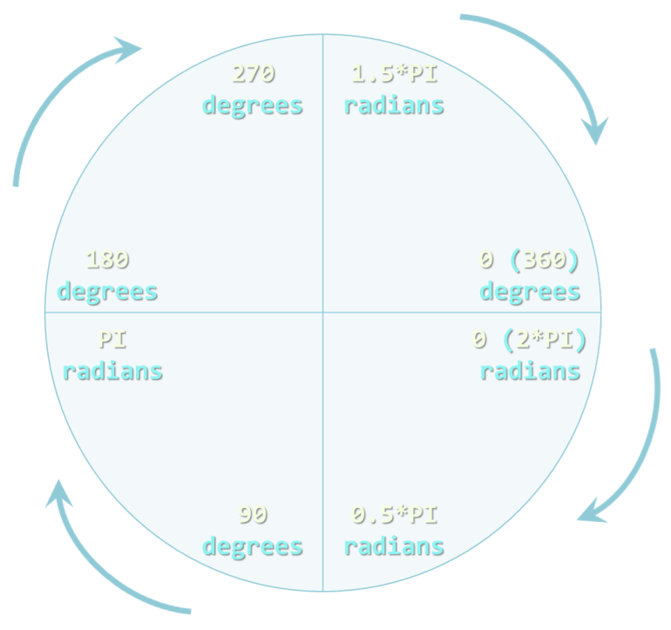

# Drawing Ellipses: Example

* To draw ellipses, a path must be started:

ctx.beginPath();

* Draw a full circle:

//clockwise

ctx.arc(x, y, r, 0, 2*Math.PI);

//counter clockwise

ctx.arc(x, y, r, 2*Math.PI, 0, true);

* Draw a segment of an ellipse:

//The smaller part (clockwise)

ctx.arc(x, y, r, Math.PI/2, 2*Math.PI);

//the bigger part (counterclockwise)

ctx.arc(x, y, r, Math.PI/2, 2*Math.PI, true);

# *Drawing Ellipses and Segments - Live Demo*

# Drawing Circular Sectors

* A circular sector is the portion of a circle enclosed by two radiuses
* The Canvas has no built-in methods for creating circular sectors
  + Yet, the Canvas supports paths
* A circle sector can be done by creating a sector and then a line to the center of the circle

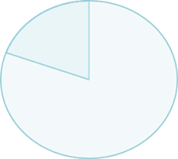 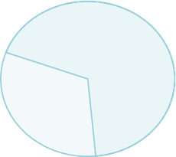

# Drawing Circular Sectors: Example

* **context.closePath()** connects the first and the last dots from the Path

function drawSector(x, y, r, from, to, isCounterClockwise) {

ctx.beginPath();

ctx.arc(x, y, r, from, to, isCounterClockwise);

ctx.lineTo(x, y);

ctx.closePath();

ctx.stroke();

}

# *Drawing Circular Sectors - Live Demo*

# Drawing Curves - Quadratic and Bezier

# Drawing Curves with the Canvas

* The Canvas supports two types of curves:
  + **Quadratic** curves
    - A simple curve drawn based on a control point
  + **Bezier** curves
    - A more complex curve based on two control points
* Both quadratic and Bezier curves are done using a path

# Quadratic Curves

* Quadratic curves are basic curves
  + Using **two context points** and a **control point**
    - The first is the last point from the path (sx, sy)
    - The second is the one from the curve (cx, cy)
  + context.quadraticCurveTo(cx, cy, ex, ey)

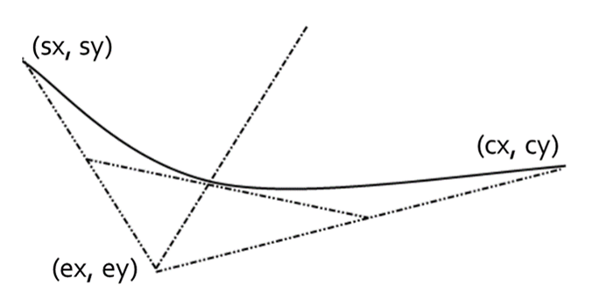

# *Quadratic Curves - Live Demo*

# Bezier Curves

* Bezier curves are like quadratic curves, but with **two context** and **two control** points

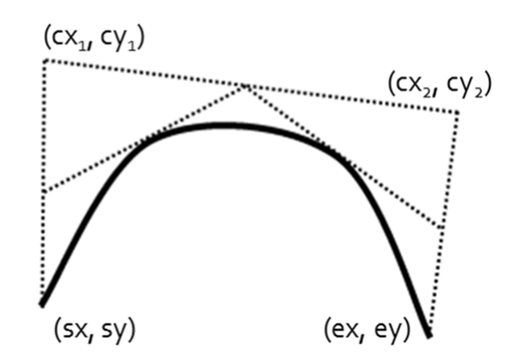

# *Bezier Curves - Live Demo*

# Drawing Text in Canvas - With styles

# Drawing Text

* The HTML5 canvas can also **draw text**:
  + Methods:
    - context.fillText (text, x, y) – fills the given text
    - context.strokeText (text, x, y) – draws only the border of the text
  + Properties:
    - context.font – sets the font size and font family of the text
    - context.fillStyle – the fill color of the text
    - context.strokeStyle – the stroke color of the text

# Drawing Text: Example

* Draw the text 'Telerik Academy'
  + Filled with **yellowgreen** color, stroked with **dark green** color
  + Font family – Arial
  + 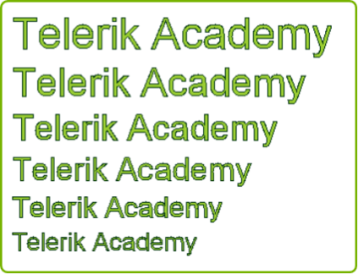Font sizes – from 28px to 48px

var minFontSize = '28';

var currentFontSize = 48;

while (minFontSize <= currentFontSize) {

ctx.font = currentFontSize + 'px ' + 'Arial';

ctx.fillText(text, x, y);

ctx.strokeText(text, x, y);

y += currentFontSize + offset;

currentFontSize -= 4;

}

# *Drawing Text in Canvas - Live Demo*

# Canvas Styles - Colors and Stuff

# Canvas Styles

* The canvas supports two styles
  + Styles for **fill** and **stroke**
    - Can be either a solid color or pattern
  + Styles for **types of stroke**
    - Dashed or solid
    - Done using kind of workaround

# *Canvas Styles - Live Demo*

# Canvas Transformations - scale(), rotate()

* The Canvas can do transformations
  + i.e. it can be rotated, scaled or transformed
* context.scale(dx, dy) – all coordinates and points are scaled
  + fillRect(X, X, W, H) will draw a rectangle
  + At position **(dx X, dy Y)**
  + With width **(dx* W)** and height **(dy* H)**
* context.rotate(D) – all drawing is rotated with angle **D degrees**

# *Canvas Transformations - Live Demo*

# Canvas Per-pixel Manipulation (Change only portions of the canvas)

# Canvas Per-pixel Manipulation

* Canvas supports **per-pixel manipulation**
  + All the pixels can be **manipulated one-by-one**
* Use the context.getImageData(x, y, w, h)
  + Returns the image data object
    - The image data is for the rectangle with **top-left corner at (x, y)** with **width w** and **height h**
  + The image data contains **an array of numbers** for each of the pixels
* The array of pixels holds values between 0 and 255
  + Each value represents a **color component** from **RGBA**
  + The pixels are grouped in triples in the array
  + The color values for the **i-th pixel** are at positions:
    - pixels[i] holds the **RED** component
    - pixels[i+1] holds the **GREEN** component
    - pixels[i+2] holds the **BLUE** component

# Canvas Per-pixel Manipulation: Example

* Invert all the colors of an canvas
  + Change each color component CC with 255-CC

var i,

len,

width = canvas.width,

height = canvas.height,

imageData = ctx.getImageData(150, 150, width, height),

data = imageData.data;

for(i = 0, len = data.length; i < len; i+=4){

data[i+1] = 255 - data[i+1];

data[i] = 255 - data[i];

data[i+2] = 255 - data[i+2];

}

ctx.putImageData(imageData, 0, 0);

# *Canvas Per-pixel Manipulations - Live Demo*